Name | Prathmesh V. Patil
Roll no | 24204C0025
Batch | 2
Subject name | Python Programming & Data Structure
Teacher Name | Ms. Rasika Patil

Experiments | 12
Title | Implement searching techniques using python  a) Linear Search  b) Binary Search

Programming Questions with Answer
1 | Program for Linear Search
SCRIPT | # Linear Search Program  def linear_search(arr, key):  for i in range(len(arr)):  if arr[i] == key:  return i # return index if found  return -1 # return -1 if not found  # Main Program  arr = [10, 25, 30, 45, 60, 75]  key = int(input("Enter number to search: "))  result = linear_search(arr, key)  if result != -1:  print("Element found at index:", result)  else:  print("Element not found")
OP | 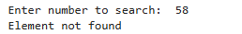
2 | Program for Binary Search
SCRIPT | def binary_search(arr, key):  left = 0  right = len(arr) - 1  while left <= right:  mid = (left + right) // 2  if arr[mid] == key:  return mid  elif arr[mid] < key:  left = mid + 1  else:  right = mid - 1  return -1  # Take input in one line (space separated numbers)  arr = list(map(int, input("Enter sorted numbers (space separated): ").split()))  key = int(input("Enter element to search: "))  result = binary_search(arr, key)  if result != -1:  print(f"Element found at index {result}")  else:  print("Element not found")
OP | 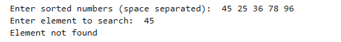
3 | Program to search for a character in a string (Linear Search logic)
SCRIPT | def linear_search(string, key):  for i in range(len(string)):  if string[i] == key:  return i # Return index if found  return -1 # Return -1 if not found  # Taking input from user  text = input("Enter a string: ")  char = input("Enter character to search: ")  result = linear_search(text, char)  if result != -1:  print(f"Character found at index {result}")  else:  print("Character not found")
OP | 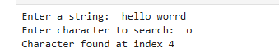
Debugging Questions with Corrected Answers
1 | Debug the following code  Wrong code:  arr = [1,2,3]  for i in arr:  if arr[i] == 2:  print("Found")
OP | Error:  Correct code:
2 | Debug the following code  Wrong code:  low = 0  high = len(arr)  mid = (low + high) / 2
OP | Error: IndexError: list index out of range  Correct code: arr = [1, 2, 3]  for i in range(len(arr)):  if arr[i] == 2:  print("Found")
Conclusion | In a for i in arr loop, i represents the value, not the index.  Use if i == 2 or loop with range(len(arr)) if you need the index.
Performance Indicators |  | Teachers Dated and Signature
Process Related  (15 M) | Product Related  (10 M) | Total (25 M)

